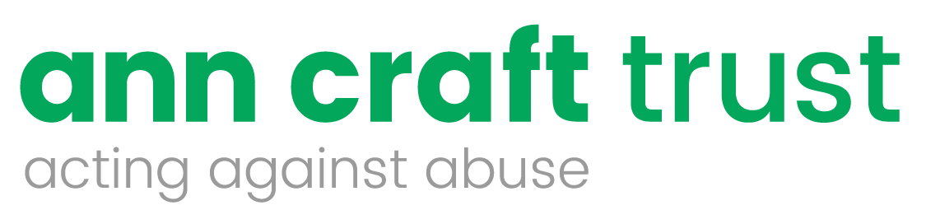
Could you become a Trustee for the Ann Craft Trust?

The Ann Craft Trust is a leading UK authority on Safeguarding Adults and Young People. We are looking for committed individuals who have an interest in safeguarding to join the Ann Craft Trust Board of Trustees
You will be joining the Ann Craft Trust as we enter our thirtieth year of acting against abuse. This is an exciting time for us as we seek to continue and expand our safeguarding training, research and audits across a broad range of sectors; including sport and activity, health and social care and education to name a few.
As a trustee you will have a crucial leadership role and contribute to our aim of safeguarding young people and adults at risk in all UK communities.
As a trustee you will:
- Shape the strategic direction of the charity
- Increase your professional networks in the safeguarding sector and beyond
- Join a friendly and supportive team who value innovative practice
We are keen to improve the diversity of our Board, so that it better represents the people we support. ACT is committed to equality, diversity and the creation of an inclusive approach in all we do. We value the skills, experience and perspective that a diverse and representative Board of Trustees offers us in terms of our ability to deliver this.
We are looking for people who have skills, experiences and knowledge in one or more of the following areas:
- Experience of running a voluntary organisation
- Experience of Board level governance responsibilities, particularly financial and legal accountabilities and adhering to regulations in these areas
- Business planning and development
- Knowledge of the risks to, and safeguarding needs of, young people and adults at risk
- Interest in and knowledge of safeguarding research, policies, processes and procedures and experience of enacting these in diverse UK communities
To ensure the Board of Trustees is best able to support the work of the Ann Craft Trust we particularly welcome applications from members of groups that are currently under-represented, including people from Black, Asian and Minority Ethnic communities, people with a disability, experts by experience and people who identify as LGBTQ.
As a trustee, you will participate in quarterly Trustee meetings, held on weekdays, and the Annual General Meeting in November. All meetings are currently held via MS Teams, but when circumstances allow, some future meetings may take place in ACT offices, in the University of Nottingham. Travel expenses will be reimbursed for any necessary travel.
Please submit your interest by sending us a CV and covering letter detailing how your skills and experiences would support the continuing work of the Ann Craft Trust with particular reference to the points above.
In addition, we would ask you to complete the Equalities Monitoring Form below
Please send to Deborah Kitson, ACT CEO.
deborah.kitson@nottingham.ac.uk
Following receipt of your CV and letter, you will be contacted for an initial informal discussion by phone with either one of the current Trustees or the CEO

Equality and diversity monitoring form

Ann Craft Trust wants to build an accurate picture of the make-up of applicants for positions, in encouraging equality and diversity.

The organisation needs your help and co-operation to enable it to do this but filling in this form is voluntary. The information provided will be kept confidential and will be used for monitoring purposes.

If you have any questions about the form contact Deborah Kitson
Gender Male * Female * Intersex * Non-binary * Prefer not to say *
If you prefer to use your own gender identity, please write in:

Is the gender you identify with the same as your gender registered at birth?
Yes ☐ No ☐ Prefer not to say ☐

Age 16-24 * 25-29 * 30-34 * 35-39 * 40-44 * 45-49 * 50-54 * 55-59 * 60-64 * 65+ * Prefer not to say *
What is your ethnicity?
Ethnic origin is not about nationality, place of birth or citizenship. It is about the group to which you perceive you belong. Please tick the appropriate box

Asian or Asian British
Indian * Pakistani * Bangladeshi * Chinese * Prefer not to say *
Any other Asian background, please write in:

Black, African, Caribbean or Black British
African * Caribbean * Prefer not to say *
Any other Black, African or Caribbean background, please write in:

Mixed or Multiple ethnic groups
White and Black Caribbean * White and Black African * White and Asian * Prefer not to say * Any other Mixed or Multiple ethnic background, please write in:

White
English * Welsh * Scottish * Northern Irish * Irish *
British * Gypsy or Irish Traveller * Prefer not to say *
Any other White background, please write in:

Other ethnic group
Arab * Prefer not to say * Any other ethnic group, please write in:
Do you consider yourself to have a disability or health condition?
Yes * No * Prefer not to say *

What is the effect or impact of your disability or health condition on your work? Please write in here:

The information in this form is for monitoring purposes only. If you believe you need a ‘reasonable adjustment’, then please discuss this with the manager running the recruitment process if you are a job applicant.
What is your sexual orientation?
Heterosexual * Gay * Lesbian * Bisexual * Asexual * Pansexual * Undecided * Prefer not to say *
If you prefer to use your own identity, please write in:

What is your religion or belief?
No religion or belief * Buddhist * Christian * Hindu * Jewish *
Muslim * Sikh * Prefer not to say * If other religion or belief, please write in:

This form should be returned to Natascha Rock at n.rock@nottingham.ac.uk

